Setup and Execution Guide:

"The Tummy Filling Station"

**Table of Contents:**

1. Introduction
2. Download and Setup
3. Execution Steps
4. Functionalities Overview
5. Troubleshooting
6. Conclusion

**1. Introduction:**

Welcome to "The Tummy Filling Station" setup and execution guide. This document provides detailed instructions on how to download, set up, and execute the project codes. The project aims to create a user-friendly online food ordering platform using the MERN Stack (MySQL, Express, React, Node) with a focus on user authentication, restaurant management, order processing, and static page serving.

**2. Download and Setup:**

**Step 1: Download Project Codes**

1. Download the project codes from the attached zip folder.

2. Extract the downloaded zip file to a preferred location on your computer.

**Step 2: Backend Setup**

1. Navigate to the extracted folder named " Tummy-Filling-Station-main."

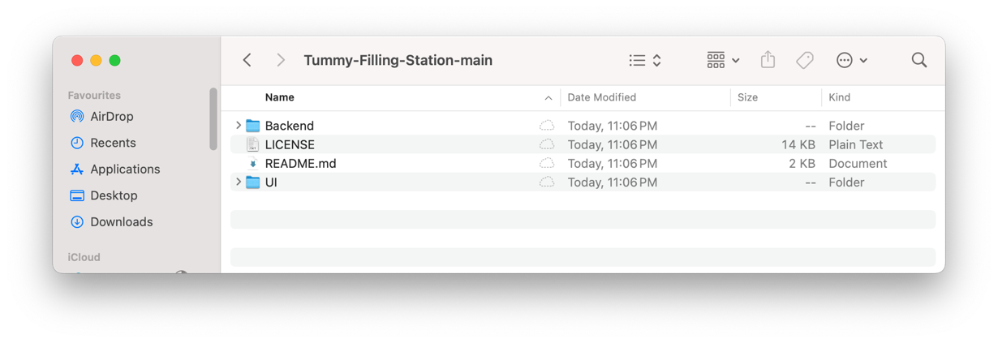

2. Open a terminal within the "Backend" folder.

3. Run the following command to create the database and install dependencies:

npm run create-db && npm install

* + This command will first create the necessary database using the **npm run create-db** script and then proceed to install backend dependencies.

4. After installation, start the backend server by running:

npm start

**Step 3: Frontend Setup**

1. Open a new terminal in the "UI" folder within the extracted project folder.

2. Run the following command to install frontend dependencies:

npm install

3. Once the installation completes, start the frontend server with:

npm start

4. Your default browser will open automatically, redirecting you to the login page of the application.

**3. Execution Steps:**

1. **Account Creation and Login**

1. On the login page, choose the "Signup" option.

2. Create a new account using a Google account or by entering your name, email, and password.

3. After signup, log in using your newly created credentials.

4. You will be redirected to the home page of the application.

1. **Exploring Functionalities**

1. Click "View Restaurants" or scroll down to browse available restaurants.

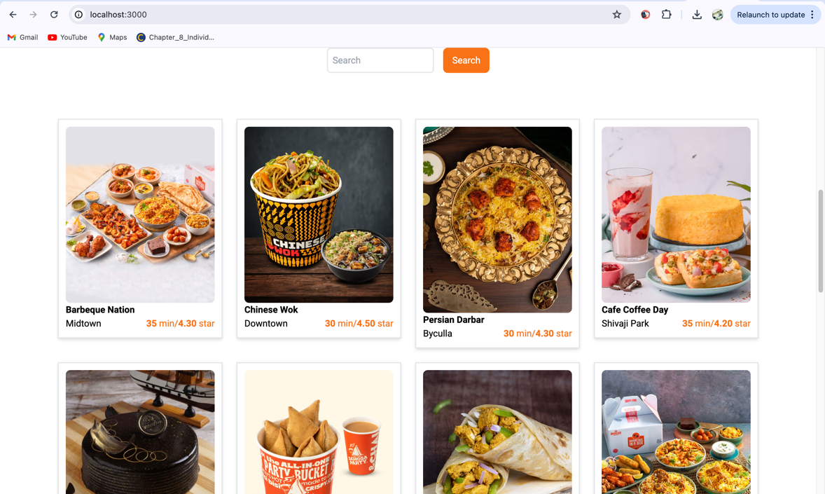

2. Use the search box to find specific restaurants.

3. Click on a restaurant's name to view its menu.

4. Expand menu categories to see food items.

5. Add desired food items to the cart.

6. 6. Proceed to checkout from the cart page **by clicking on Buy Now button**.

7. After placing an order, view order details on the "My Orders" page.

8. Explore other functionalities such as "Contact" and "Be a Seller.

9. Logout from the application by clicking on your profile name and selecting "Log out."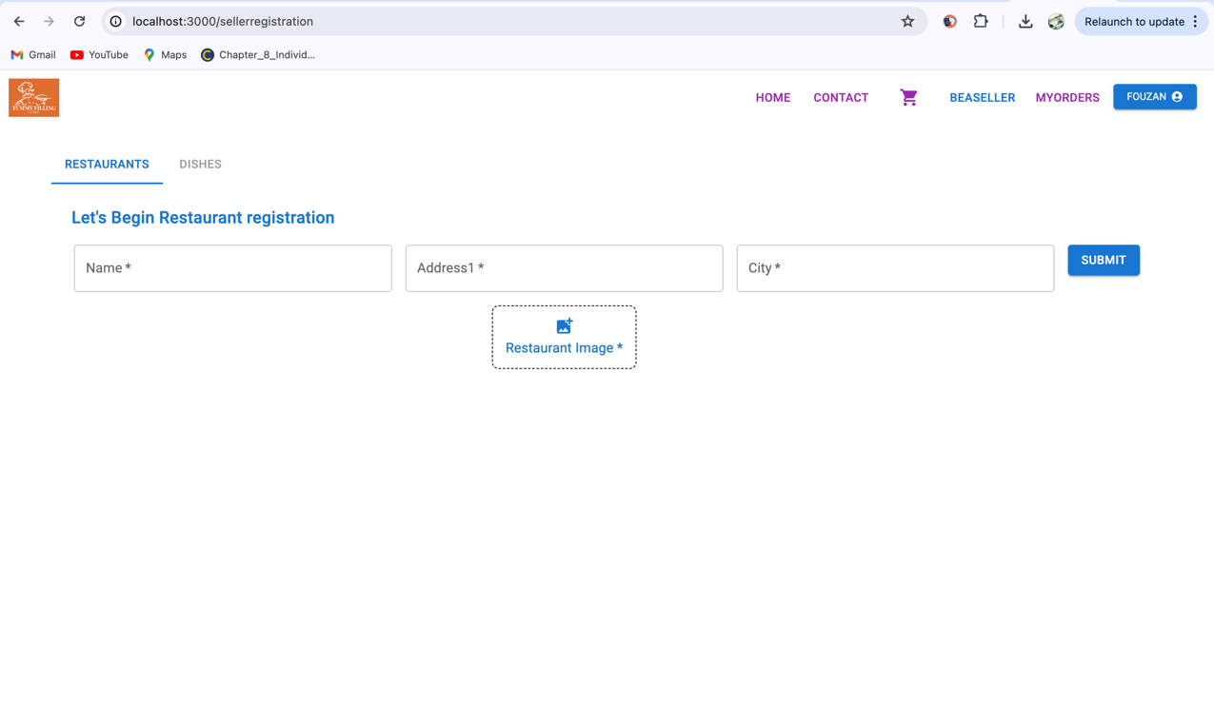

**4. Functionalities Overview:**

1. **User Authentication:** Secure login and registration system to manage user accounts using Google Sign In and normal signin by saving the newly registered user details in mysql table.
2. **Browse Restaurants:** Discover diverse dining options nearby with our Browse Restaurants feature.
3. **Browse Dishes:** Explore a wide variety of delicious dishes available on the menu.
4. **Place Orders:** Place orders quickly and easily with just a few clicks.
5. **Order Placed:** Shows the order details with the items which are ordered with date and time of the order placed.
6. **Contact Us:** Shows the means of contacting the company with any sort of feedback.
7. **BeASeller:** Enables the user to register new restaurants on our portal.

**5. Troubleshooting:**

- Make sure the password for the root user in mysql is ‘1234’

- If the application fails to start, ensure all dependencies are installed correctly.

- Check database connection details in the backend configuration files.

- Clear browser cache and cookies if facing unexpected behavior.

- Install 'Allow CORS' extension to your desktop and turn it on, to make the api calls since we are hitting Swiggy's live API (https://chromewebstore.google.com/detail/allow-cors-access-control/lhobafahddgcelffkeicbaginigeejlf)

**6. Conclusion:**

In conclusion, "The Tummy Filling Station" offers a comprehensive online food ordering platform with a range of functionalities aimed at enhancing user experience for both sellers and buyers. By following the setup and execution steps outlined in this document, users can successfully deploy and explore the project's features.This document provides a detailed guide on setting up and executing "The Tummy Filling Station" project. Enjoy exploring the world of online food ordering!